**MS**

**PowerPoint**

**Class Five**

**Lab 22**

|  |
| --- |
| Lab Objectives:  * Transition * PowerPoint Animation |

# PowerPoint Transition

## In Microsoft PowerPoint, slide transitions are motion effects that occur in Slide Show view when you move from one slide to the next during a presentation.

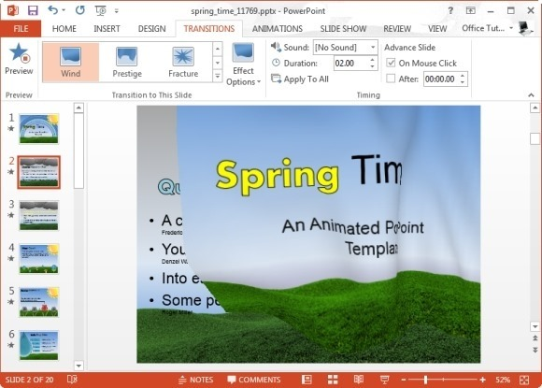

## You can control the speed, add sound, and even customize the properties of transition effects. To add a transition first of all select a slide in the left hand panel that contains the Slides and Outline tabs (I'd keep it simple and work in the Slides tab).

## The transition will occur immediately before the selected slide is displayed. Click Transitions > Transition To This Slide, and then click on the transition you want to use. If you want to see a larger selection of transitions, click on the more button (the down arrow at the bottom right of the group.

[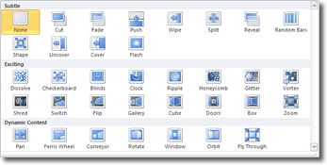](http://www.electricteacher.com/images/powerpoint-transitions.gif)

## When you hover over a thumbnail image of a transition, you can see a live preview of it applied to your slide. When you move the cursor away, the preview is removed.

## If, after having applied a transition to the selected slide, you decide that you want the transition applied to all slides, click on the Apply To All button in the Timing Group on the same tab.

# Animation For PowerPoint

## To add a custom animation to an object in Microsoft PowerPoint, first of all select the object, then click animation in the ribbon to see all the animation options we have at our disposal. We can see a few thumbnail images representing entrance effects in the animation group.

## IMG_256

## That's not a very big selection of effects. To see more effects, click on the dialogue launcher at the bottom right of the Animation group. A more comprehensive selection of effects is then displayed in a thumbnail gallery, in the categories of:

## Entrance - this kind of animation brings the object onto the PowerPoint slide from a location off the slide

## Emphasis - once the object is on the slide, you can give it some emphasis with this kind of animation

## Exit - animations in this category remove the object from a slide

## Motion Paths - applying this kind of animation allows us to plot a path for the object to follow

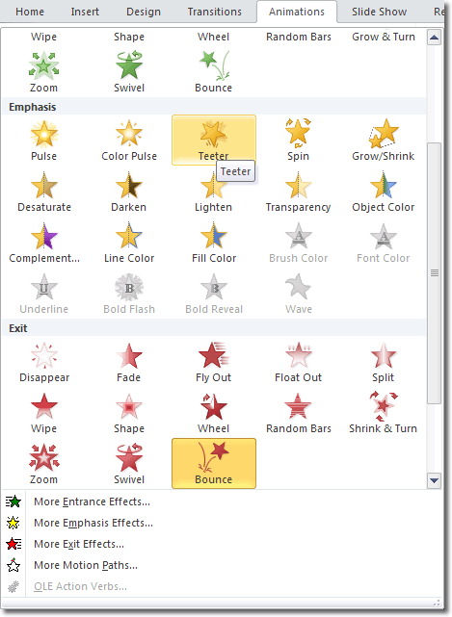

# Previewing Animations

## When you hover your mouse over the thumbnail image of an animation, you can see a preview of what that animation would look like if applied. The animation plays once. You also get to see what the animation looks like when you actually apply it to the object. If you want to see a preview of the animation at any other time, click the Preview button to the far left of the Animations tab.

# Inserting Sound In PowerPoint

## Careful use of sound in your Microsoft PowerPoint presentation can do wonders to enhance it. However, it's easy to get carried away and if you are not careful, you may confuse and distract the audience too much from the message you are trying to convey. Bear this in mind and be careful to use sound clips sparingly. Used wisely, sound (and video) effects can quickly catch your viewers’ attention.

## There are a few different ways to add a sound clip in PowerPoint.

# PowerPoint Sound Clips

## To insert a sound clip into your PowerPoint presentation, click Insert > Media > Audio. You'll notice that the audio button is split into two. Click on the lower half of the button and you'll find the following options available to you:

## IMG_256

## We'll go through each option now.

# Audio From File

This is the most straight forward option. If you have a sound file stored somewhere on your computer, use this option to navigate to it, select it and insert it. The icon representing a sound clip is inserted onto the slide you had selected.

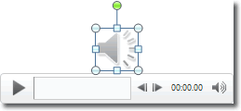

## While the sound clip is selected, you will be able to see the basic sound playback tools below the clip: play, rewind, fast forward and volume controls. You can also position the playback point to a specific place in playback using the timeline. The progress in minutes and seconds also appears to the right of the timeline, to let you know how far through the recording you've progressed.

## While the audio clip is selected, you'll also see the Audio Tools contextual tab displayed in the ribbon, allowing you to perform a variety of audio tasks on the clip.

## IMG_258

## The Format tab mostly contains commands for use with video, but the Playback tab can be used with sound clips.

# Clip Art Audio

## You can use the Clip Art library to insert pre made audio clips in much the same way that you would insert Clip Art images. When you click The Clip Art Audio option, the Clip Art panel appears to the right of the work space but the Results should be selection list is set to Audio.

## IMG_259

## Type in the type of sound you need into the search box and press Enter or click Go. A selection of sound clips will be displayed for you to insert. Click on a particular clip and it will be inserted.

# Record Audio

## The record audio option gives you the ability to record your own sound clip within PowerPoint. All you need is a microphone to record your voice. When you take this option, PowerPoint displays a dialogue box that you can use to start and stop recording your voice. Type the name of the clip in the Name box and then click the round and red record button on the right. Stop the recording by clicking the blue rectangle button in the centre and start playback using the blue triangle button on the left.

## IMG_260